ReactJS Hands-On Lab
Conditional Rendering (ticketbookingapp)

Objective
The goal of this lab was to understand conditional rendering in React — showing different UI depending on the application's state, using element variables, and controlling when a component does or doesn't render. I applied this to a simple flight ticket booking scenario where a guest user sees one view and a logged-in user sees another.

What I Did
- Created a new React app named "ticketbookingapp" using create-react-app inside my ReactJS-HOL project folder.
- Created a GuestGreeting component that displays "Please sign up." for users who are not logged in.
- Created a UserGreeting component that displays "Welcome back" for users who are logged in.
- Created a Greeting component that checks an isLoggedIn prop and conditionally returns either UserGreeting or GuestGreeting — this is the core conditional rendering logic.
- Created LoginButton and LogoutButton components, each taking an onClick prop.
- Used state in the main App component (isLoggedIn: false by default) along with handleLoginClick and handleLogoutClick methods to toggle it.
- Used an element variable ("button") inside render() to decide whether to show the Login button or the Logout button, based on the current state.
- Ran the app with npm start and tested both the guest view and the logged-in view by clicking Login and Logout.

1. Project Setup
I opened the terminal in VS Code, navigated into the ReactJS-HOL/12. ReactJS-HOL folder, and ran create-react-app to scaffold the ticketbookingapp project.
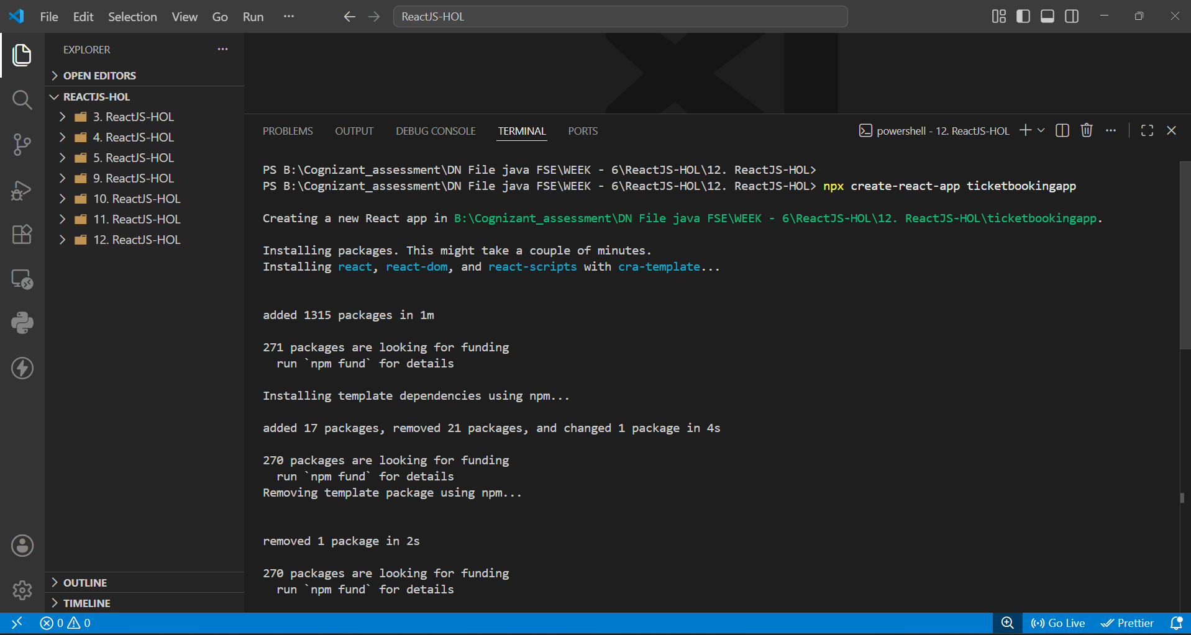
Fig 1: Creating the ticketbookingapp project with create-react-app
Once the packages finished installing, the project was created successfully inside the correct folder.
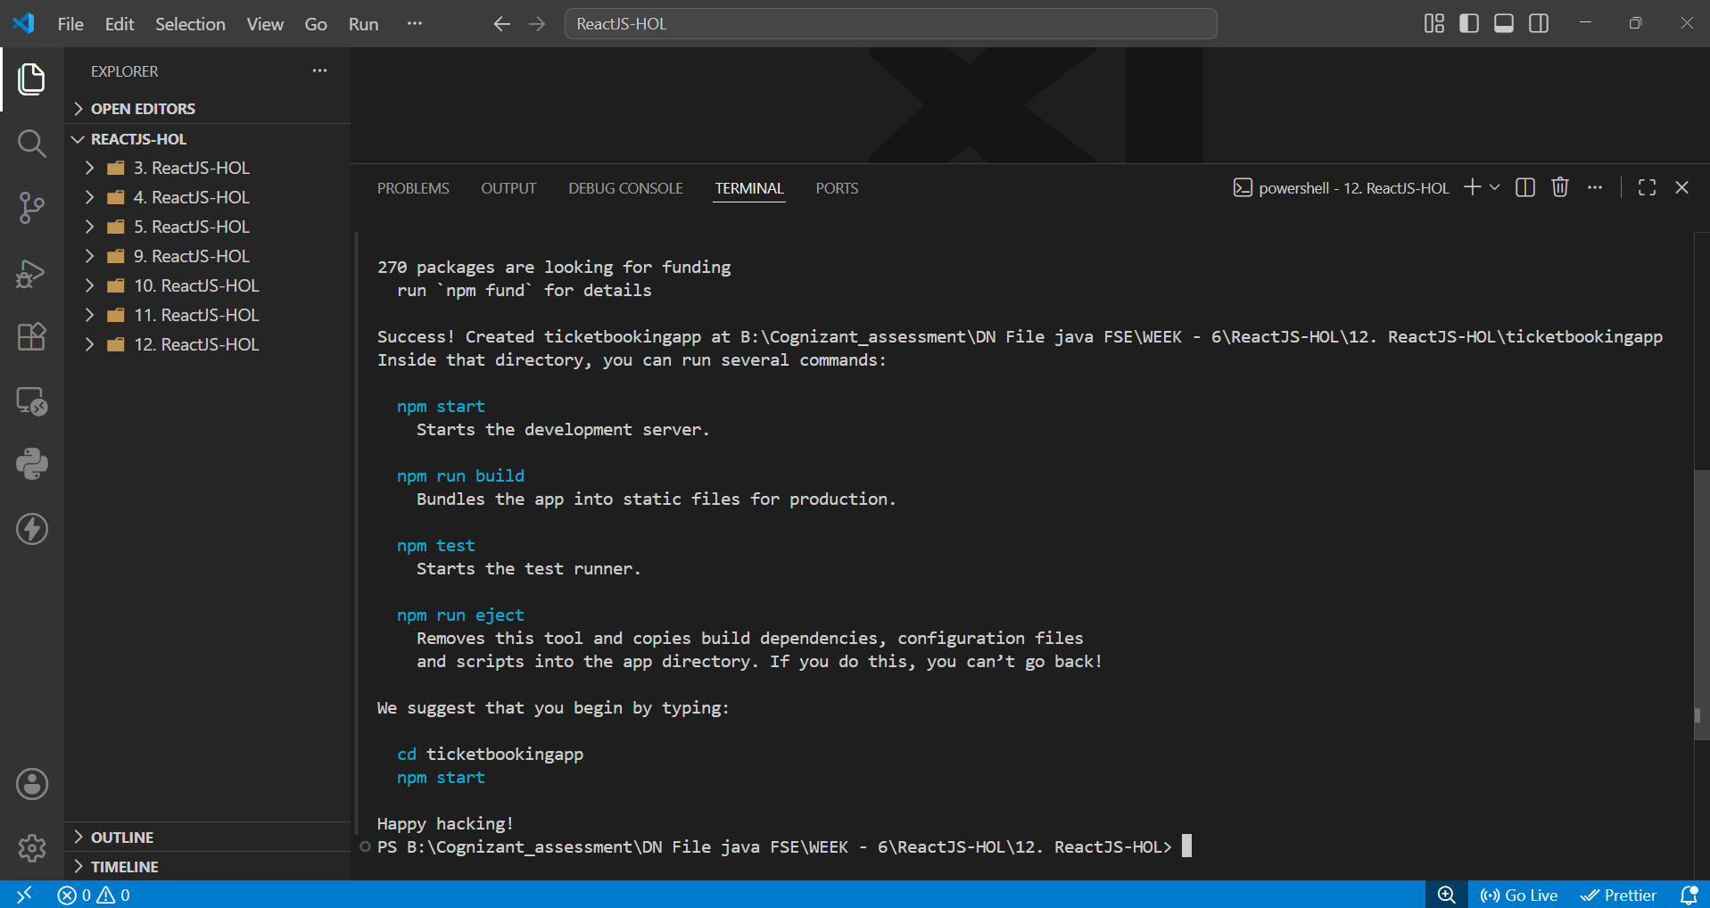
Fig 2: Project created successfully
After writing the App.js code with the Greeting, GuestGreeting, UserGreeting, LoginButton and LogoutButton components, I ran npm start and the app compiled without errors.
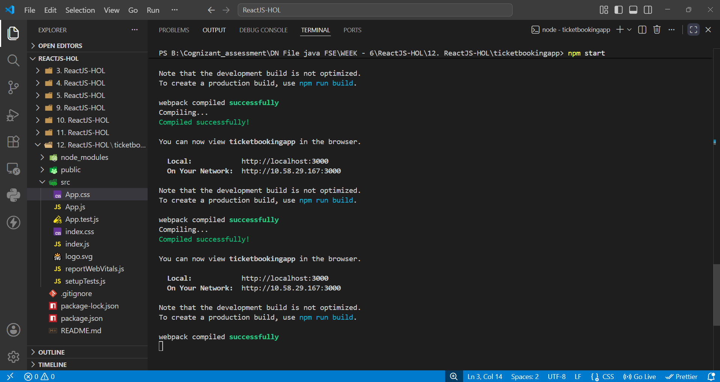
Fig 3: App compiled successfully and running on localhost:3000

2. Guest View — Not Logged In
On page load, isLoggedIn is false by default, so the Greeting component renders GuestGreeting. The page shows "Please sign up." along with a Login button.
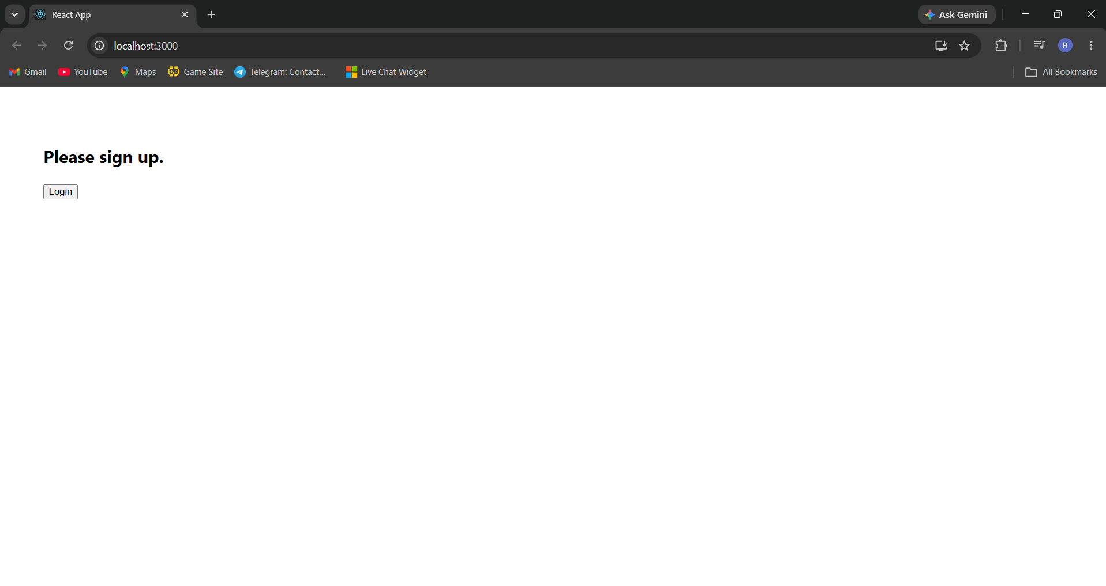
Fig 4: Guest view showing "Please sign up." and the Login button

3. User View — Logged In
Clicking the Login button updates the state (isLoggedIn: true). This causes Greeting to conditionally render UserGreeting instead, showing "Welcome back" along with a Logout button. Clicking Logout switches it back to the guest view, confirming the conditional rendering works both ways.
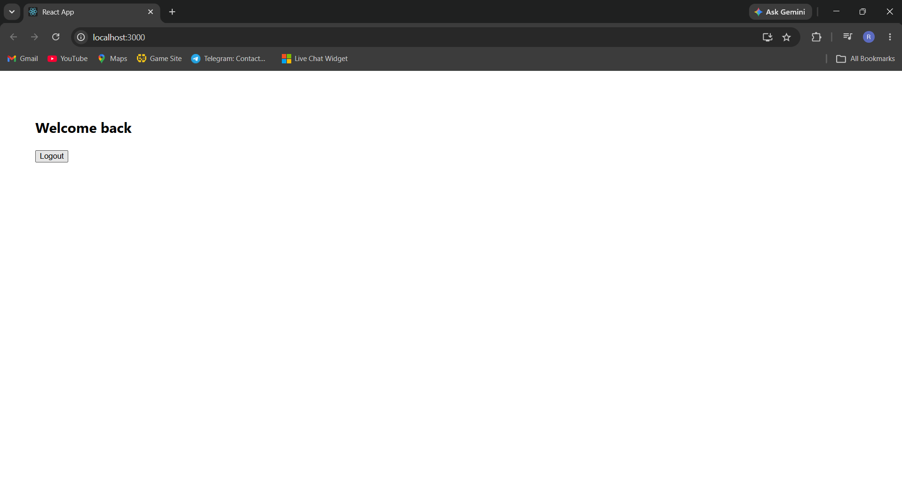
Fig 5: User view showing "Welcome back" and the Logout button after login

Conclusion
This lab helped me understand how conditional rendering works in React — using if/else inside a component to decide what to return, using element variables to hold JSX before rendering it, and controlling which of two components (Login/Logout, Guest/User) is shown based on state. The final app correctly toggles between the guest and logged-in views exactly as expected.

